DATABASE INITIALIZATION

-- DROP DATABASE employee_db;

CREATE DATABASE employee_db;
USE employee_db;

-- Create Departments table
CREATE TABLE Departments (
dept_id INT PRIMARY KEY,
dept_name VARCHAR(255) NOT NULL
);

-- Insert data into Departments table
INSERT INTO Departments (dept_id, dept_name) VALUES
(101, 'HR'),
(102, 'Finance'),
(103, 'IT');

-- Create Employee table
CREATE TABLE Employee (
emp_id INT PRIMARY KEY AUTO_INCREMENT,
emp_name VARCHAR(255) NOT NULL,
dept_id INT,
FOREIGN KEY (dept_id) REFERENCES Departments(dept_id)
);

-- Insert data into Employee table
INSERT INTO Employee (emp_name, dept_id) VALUES
('John', 101),
('Mary', 102),
('Steve', 101),
('Alice', 103),
('Bob', 102);

-- Create Projects table
CREATE TABLE Projects (
project_id INT PRIMARY KEY,
project_name VARCHAR(255) NOT NULL,
dept_id INT,
FOREIGN KEY (dept_id) REFERENCES Departments(dept_id)
);
-- Insert data into Projects table
INSERT INTO Projects (project_id, project_name, dept_id) VALUES
(201, 'Website', 101),
(202, 'Mobile App', 101),
(203, 'Accounting', 102),
(204, 'Networking', 103);
SOLUTIONS

1.
SELECT empTable.emp_name, deptTable.dept_name
FROM Employee empTable
INNER JOIN Departments deptTable ON empTable.dept_id = deptTable.dept_id;

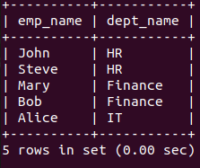

2.
SELECT empTable.emp_name, proj.project_name
FROM Employee empTable
LEFT JOIN Projects proj ON empTable.dept_id = proj.dept_id;

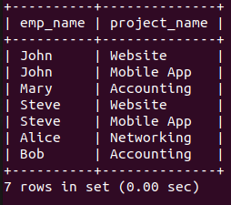

3.
SELECT proj.project_name, empTable.emp_name
FROM Projects proj
LEFT JOIN Employee empTable ON proj.dept_id = empTable.dept_id;

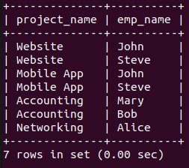

4.
SELECT empTable.emp_name, deptTable.dept_name
FROM Employee empTable
FULL OUTER JOIN Departments deptTable ON empTable.dept_id = deptTable.dept_id;

OR

SELECT empTable.emp_name, deptTable.dept_name
FROM Employee empTable
LEFT JOIN Departments deptTable ON empTable.dept_id = deptTable.dept_id
UNION
SELECT empTable.emp_name, deptTable.dept_name
FROM Employee empTable
RIGHT JOIN Departments deptTable ON empTable.dept_id = deptTable.dept_id;

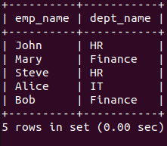

5.
SELECT emp2Table.emp_name
FROM Employee emp1Table
JOIN Employee emp2Table ON emp1Table.dept_id = emp2Table.dept_id
WHERE emp1Table.emp_name = 'John' AND emp2Table.emp_name != 'John';

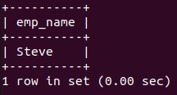

6.
SELECT deptTable.dept_name, COUNT(empTable.emp_id) as employee_count
FROM Departments deptTable
LEFT JOIN Employee empTable ON deptTable.dept_id = empTable.dept_id
GROUP BY deptTable.dept_name;

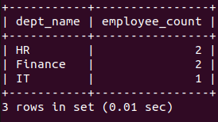

7.
SELECT deptTable.dept_name, COUNT(empTable.emp_id) as emp_count
FROM Employee empTable
RIGHT JOIN Departments deptTable ON empTable.dept_id = deptTable.dept_id
GROUP BY deptTable.dept_name;

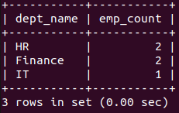

8.
SELECT DISTINCT empTable.emp_name
FROM Employee empTable
JOIN Departments deptTable ON empTable.dept_id = deptTable.dept_id
JOIN Projects proj ON deptTable.dept_id = proj.dept_id
WHERE deptTable.dept_name = 'HR';

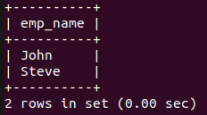

9.
SELECT empTable.emp_name, deptTable.dept_name
FROM Employee empTable
JOIN Departments deptTable ON empTable.dept_id = deptTable.dept_id
WHERE empTable.emp_name LIKE 'S%';

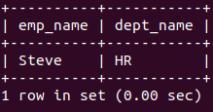

10.
SELECT empTable.emp_name, deptTable.dept_name, proj.project_name
FROM Employee empTable
JOIN Departments deptTable ON empTable.dept_id = deptTable.dept_id
JOIN Projects proj ON deptTable.dept_id = proj.dept_id;

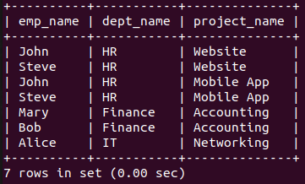

11.
SELECT DISTINCT deptTable.dept_name
FROM Departments deptTable
JOIN Employee empTable ON deptTable.dept_id = empTable.dept_id;

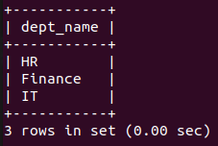

12.
SELECT emp2Table.emp_name
FROM Employee emp1Table
JOIN Employee emp2Table ON emp1Table.dept_id = emp2Table.dept_id
WHERE emp1Table.emp_name = 'Steve';

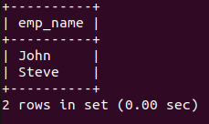

13.
SELECT empTable.emp_name
FROM Employee empTable
LEFT JOIN Projects proj ON empTable.dept_id = proj.dept_id
WHERE proj.project_id IS NULL;

14.
SELECT DISTINCT empTable.emp_name
FROM Employee empTable
WHERE empTable.emp_id NOT IN (
SELECT emp2Table.emp_id
FROM Employee emp2Table
JOIN Departments deptTable ON emp2Table.dept_id = deptTable.dept_id
JOIN Projects proj ON deptTable.dept_id = proj.dept_id
WHERE deptTable.dept_name = 'HR'
);

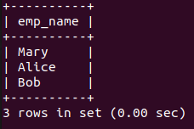

15.
SELECT DISTINCT deptTable.dept_name
FROM Departments deptTable
JOIN Employee empTable ON deptTable.dept_id = empTable.dept_id;

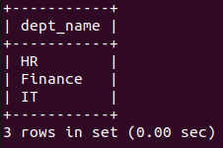

16.
SELECT empTable.emp_name, deptTable.dept_name
FROM Employee empTable
JOIN Departments deptTable ON empTable.dept_id = deptTable.dept_id
ORDER BY deptTable.dept_name, empTable.emp_name;

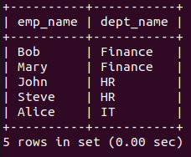

17.
SELECT empTable.emp_name, projTable.project_name
FROM Employee empTable
CROSS JOIN Projects projTable;

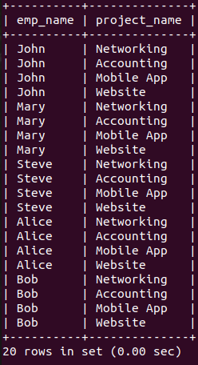

18.
SELECT deptTable.dept_name, COUNT(empTable.emp_id) as emp_count
FROM Departments deptTable
JOIN Employee empTable ON deptTable.dept_id = empTable.dept_id
GROUP BY deptTable.dept_name
HAVING COUNT(empTable.emp_id) > 1;

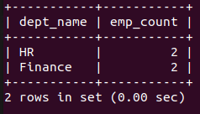

19.
SELECT empTable2.emp_name
FROM Employee empTable1
JOIN Employee empTable2 ON empTable1.dept_id = empTable2.dept_id
WHERE empTable1.emp_name = 'Alice' AND empTable2.emp_name != 'Alice';

20.
SELECT empTable.emp_name, deptTable.dept_name
FROM Employee empTable
JOIN Departments deptTable ON empTable.dept_id = deptTable.dept_id
WHERE deptTable.dept_id BETWEEN 101 AND 102;

